Training Manual - AccessibilityOz Exhibit Booth
Draft June 8, 2018

What to Expect
This training manual is intended to be built on, over time. It contains various elements to help you hook and engage high quality prospects.
- It defines the market to help you better understand how the AccessibilityOz tools and services fit in the a11y space. It identifies targets and overviews of conferences.
- It also provides best practices, tips and suggestions from a marketing/sales perspective including funnels and conversational techniques to help build relationships.
- Look at the end for helpful hints for success which you can employ leading up to, during and after the conference.

Table of Contents
What to Expect 1
Table of Contents 1
The A11y Market 3
Laws of the Land 3
In the United States 3
AccessibilityOz’s Corner of the U.S. Market 3
Prospect Relationship Building 3
Targets 4
Buyers 4
Tryers 4
Referrers 4
Partners 4
Candidates 4
Swag Lovers 4
Conferences 5
Accessing Higher Ground 5
California State University Northridge Assistive Technology Conference 5
M-Enabling Summit 5
ICT Testing Symposium 6
Ramps 6
Early Phase 6
Midway Through 7
Mature 7
Size Counts! 7
Marketing & Sales 8
Funnels 8
What is a funnel? 8
Funnels + Ramps 8
Relationship Building 10
Questions 10
How Personal? 10
Building-Up the Conversation 10
Personas 11
Test Yourself 11
Answers 12
Helpful Hints 13
Things to think about before your trip: 13
Notes for while you are there: 13
Post Conference to-do: 14

The A11y Market

Laws of the Land
The accessibility market ebbs and flows with the laws of the land. Large organizations such as Microsoft and Google work towards international accessibility standards, some from countries with guidelines that are much stricter than those in the U.S. The Canadian province of Ontario is regarded as having some of the highest standards. The European Union has a unique set of standards. Australia follows {fill in.} Many standards are influenced by “WCAG” or the Web Content Accessibility Guidelines, created by the W3C.

In the United States
Government institutions and programs are mandated to follow Section 508 but many of them simply do not.
For private industry, U.S. courts typically mandate compliance at WCAG standards. California trends towards even tougher standards which often means software/application vendors will strive to meet California standards.
Airlines are mandated by separate laws under the Department of Transportation.
Large organizations such as universities and tech companies may want to do the “right thing” and make their products accessible to everyone but many aren’t driven to invest much into accessibility until they are faced with lawsuits or warnings from the Department of Justice.

AccessibilityOz’s Corner of the U.S. Market
AccessibilityOz offers a host of products and services that address a variety of needs across the accessibility space. Our primary target is a customer who will need an automated testing solution, meaning they would be interested in licensing OzART for their internal use. The kind of prospective client ready for our tool will be quite mature in their accessibility journeys. They already have roadmaps and SMEs as well as a dedicated staff member who will run OzART at regular intervals and also implement and coordinate fixes to improve accessibility. A HOT prospect is someone who is working with a budget and timeline to choose between us and another consultancy service that has an automated testing tool. You may recognize these prospects by their pointed questions about the functionality of OzART and how it would integrate with their existing systems or technical pain points.
It is more common for our clients to begin with an ancillary service such as an audit or PDF remediation. We are happy to offer this kind of support and ultimately hope that it helps position us at top of mind when they are ready to begin or renew a license for an automated testing tool.

Prospect Relationship Building
Large contracts like these sometimes happen very quickly but more often, they unfold slowly. Procurement processes tend to be quite formal and sometimes require multiple steps. Closing a sale often requires sign-off from various stakeholders and may take years to orchestrate. Your work at the AccessibilityOz booth is to help build relationships so we can increase our touchpoints within an organization and show that we are indeed experts. We also rely on each other to keep internal notes as we map out targets in each prospect’s ecosystem.

Targets
Our main targets are generally the “Buyers” or the “Tryers.” We also are happy to meet Referrers, Partners, Candidates and Swag Lovers.

Buyers
Buyers are making higher-level product, services and staffing decisions, lobbying for policy that will support long-term buy-in, managing accommodation budgets and complying with procurement policies. They might be the Chief Technology Officer, an Accessibility Specialist or Director of Disability Support Services. When a Buyer approaches the booth, it is likely that they are trying to determine how our offerings might fit into their broader roadmap.

Tryers
Technical Experts often come to the booth with very pointed questions about our offerings. They may be trying to solve a specific problem in their jobs or doing research so as to advise the higher-ups on where to spend money. They could be a Web Developer, an Assistive Technology Coordinator, or an Accessibility Specialist. Geeking out on accessibility with these people is the way to their hearts! Share resources and information for lasting results.

Referrers
A Referrer may work in the accessibility space but not in tech. Or they may specialize in assistive technology but not information technology. They could be a librarian or instructional technology specialist. They may be an Assistive Technology Coordinator or Direct Support Staff. It is still worth talking to them and finding out about their pain-points. They may even be willing to introduce you to a Tryer or a Buyer!

Partners
A partner may pose a B2B opportunity. In some cases they may be looking to resell our products or services. They may want to license OzART and use it for their own audits. They may ask us to run a number of audits or PDF remediation and include it in a larger scope of work. In other cases, they may offer us bulk rates so we can outsource our captions and transcripts and sell the work under the AccessibilityOz label.

Candidates
Potential employees or contractors for AccessibilityOz to help with development, sales, marketing, or testing. They may already work for our competitors.

Swag Lovers
Swag lovers are happy to enjoy our chocolates and take home our cute koalas and kangaroos but probably aren’t positioned to help refer us to anyone for business purposes. It is possible their use of our great swag may bring our brand in front of other targets. Regardless, their enjoyment of it will hopefully bring good karma. If a swag lover asks about our business, I often say something like “We offer enterprise-level tools and services related to digital accessibility.” This helps them determine if they want to learn more or bow out of the conversation.

Conferences
The bulk of our lead generation occurs at conferences. The main accessibility conferences we hit in a given year and outlined below.

Accessing Higher Ground
AHG is held in the Denver area each November and put on by the likeable Howard Kramer. The conference focus is accessibility in the higher-ed space and the about 75% of attendees are from higher-ed institutions. Course content is regarded as some of the highest quality among accessibility conferences, so people from other industries attend, as well. Expect up to 20 booths with ~1/4 of them being direct competitors. Dress is more casual – many attendees will wear cardigans and slacks or even jeans. The most common attendees are:
- Captioners, Document Remediators, Testers (tryers)
- Directors of Disability Department, Accessibility Specialists (buyers)
- Direct Service Providers, VR counsellors (referrers)

California State University Northridge Assistive Technology Conference
CSUNATC is a conference that is now moving back to Los Angeles from San Diego. Typically in March, everyone refers to this conference as “CSUN” because it is put on by the California State University of Northridge’s Disability Department. Don’t let that mislead you, however. The true nature of this conference is industry. People come from around the world with thousands in attendance and over 100 booths. This is the “it” conference with a big business feel. Half of these booths are either smaller companies demoing assistive technology or they are big business such as Google, Microsoft, IBM and Amazon. Many of these larger companies also have separate showroom suites where they hold sessions and receptions. You will also see a good proportion of people from higher education and government, here. About 5-10% of booths are direct competitors. Dress ranges from business casual to business formal. Many people wear suits. The most common attendees are:
- Web Accessibility Professionals (tryers)
- Accessibility Specialists (buyers)
- Assistive Technology Specialists (referrers)
- Users (swag lovers, candidates)
- College students learning about the industry (swag lovers)
- High school students attending in an effort to meet Stevie Wonder (swag lovers)

M-Enabling Summit
M-Enabling is a conference held in the DC area. The stated focus is mobile accessibility but really this is the accessibility conference where business intersects with government. The conference is hosted by the FCC. B2B opportunities are plentiful, here. At least 25% of attendees wear business suits. The most common attendees are:
- Accessibility Specialists for federal government (buyers and tryers)
- Accessibility Specialists for local government (buyers and tryers)
- Accessibility specialists whose functions may have more to do with lobbying, compliance and standards for their organizations (partners)

ICT Testing Symposium
The ICT Testing Symposium is the conference dedicated specifically to web accessibility testing. {Fill in} Dress code is {…} The most common attendees are:
- Users (candidates)
- Direct Competitors (partners)
- {Fill in}

Ramps
Organizations go through an exploration process as they progress along their accessibility journeys. Imagine a ramp and you can picture how someone getting started in accessibility will be looking for different solutions than what they need as their accessibility model matures. Your job at the booth is to listen to where they are at on the journey to try and see where AccessibilityOz might support them.
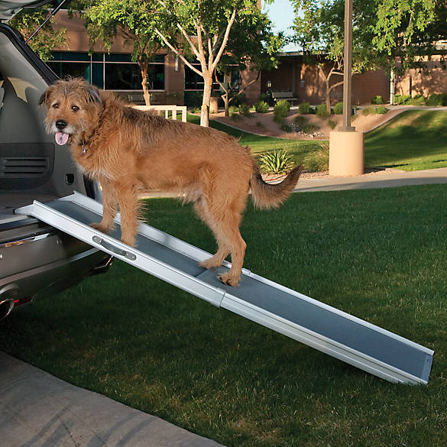

Early Phase
Early on in the process, someone may have little experience but had accessibility added to their job descriptions and now they are trying to learn everything. More urgently, they may have just gotten sued and they are scrambling to understand the industry and to determine what their action plan might entail. These people might say with a sigh “I need a road map.”

Are they ready for a meeting with Gian?
Organizations that just got sued may need a lot of different kinds of services. A meeting with Gian would be helpful so she can fully address their concerns. She may even be able to anticipate their needs in ways that hadn’t occurred to them.

Midway Through
As they progress, they can begin to assess the gap between their current level of accessibility and reaching their accessibility goals. Or they may be still determining what their accessibility goals are. Their organization may have reached a plateau with their level of accessibility and they may be trying to get more buy-in from the top.

Are they ready for a meeting with Gian?
During this information seeking phase, they are great candidates for a meeting with Gian if they indicate they are fiscally prepared to get an audit to “look under the hood” of their website.
Other types of interests such as trainings, captions, transcripts & audio descriptions, PDF remediation, or licensing one of our products like OzPlayer could be handled via email or follow-up phone call. It is also worth directing them towards informational resources such as AccessibilityOz sessions, articles and presentations.

Mature
Representatives from mature organizations understand the market and their unique role within their organization. They would never ask “how much is an audit?” because they understand that the answer is “it depends.” They might ask “what is the OzART run time” or how is OzART different from the other tools? They may also ask about OzART integrations with specific systems such as Canvas, Blackboard, Camtasia, Drupal or Sharepoint, or want to know about OzART’s user interface, if it tracks progress over time and what kind of analytics it provides?

Are they ready for a meeting with Gian?
People who are in more senior roles are usually worth meeting with, especially if they are “kicking the tires” with specific questions or indicate an RFQ is coming up.

Size Counts!
No matter where they are in the accessibility journey, if they work for larger companies such as AirBnB, Adobe, Intel, Pearson, E*Trade or Kaiser, Gian would likely be happy to have a meeting with them unless they are more junior level Tryers.

Marketing & Sales

Funnels

What is a funnel?
A sales funnel refers to the several steps a client makes to reach the purchase process. Each progressive step further down the funnel indicates a greater degree of investment in the relationship.
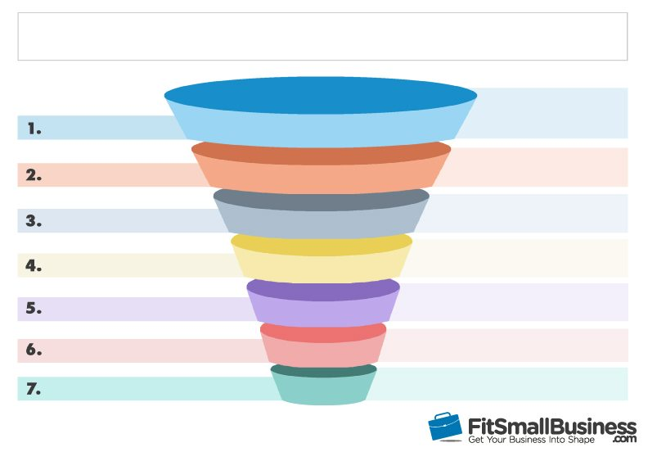

Example Conference Funnel Steps
- Attendee reads session description and decides it is of interest.
- Attendee meets AccessibilityOz staff at a networking event
- Attendee stops by booth
- Attendee goes to session
- Attendee sets meeting with Gian
- Attendee invites to AccessibilityOz to apply to their organization’s RFQ process
- Organization buys an AccessibilityOz product or service
Of course, the journey isn’t always this simple and there are lots of different ways someone may end up coming through the funnel. For example, they may not go in chronological order, they may even go backwards or skip some steps. There are many other touchpoints outside the conference, as well, on social media, the web and outside events or meetings.

Funnels + Ramps
So what is the big idea of the funnels and ramps? A customer journey may start with someone journeying down through the funnel once, starting out with a purchase of an OzWiki subscription, for example. In time, AccessibilityOz hopes they will hop through more of our funnels, moving towards higher level purchases and becoming customers for life!

+ = LIFELONG CUSTOMERS

Relationship Building
Conferences are our number one lead generator and relationship building is the most important sales focus at the conference. How can this be accomplished without feeling fake or too sales-y? Remember that people want to feel they are being listened to and valued. Asking questions and building your conversations up will go a long way!

Questions
You may be surprised how much people will share with you, with just a few questions to get the conversation going. Some people who approach the booth may want to share personal information about a trip to Australia or some other vacation, their kids, their pets, or their home remodels. Other people will be happy to share about their professional life and how their accessibility journeys are going at work.
Take time to read article about questions by the Harvard Business Review which explains the surprising power of questions.
Whatever they mention that is work-related, take notes while they talk. If they pose accessibility questions or resources you could possibly track down, make note and follow-up, later. There may be things you pick up on that aren’t appropriate to write down while they stand there, but would be worth jotting down after they walk away. If they went on about a pet, for example, that kind of tidbit may come in handy at a later conversation. Notes about how long they have worked for a company or where they were working previously might be of interest.

Possible Questions to Ask:
- What is your role at XYZ Company?
- How is accessibility looking at your company?
- Have you attended any good sessions at the conference, so far?
- Any particular sessions you are looking forward to attending?

How Personal?
It can be tricky to find the balance between getting to know your prospect on a personal level and determining where they might fit on the sales funnel. Remember, you are standing behind a booth, so it isn’t obnoxious to guide the conversation back towards business so you can advance them along the sales funnel.
On the other hand, the goal is to build up a relationship, so if you are comfortable, it may be appropriate, at times, to share personal information. How do you gauge what is appropriate to share? A safe bet is to stick to anything that might help establish commonality. For example, “I love that sports team, what a great season they had, right?” Or “my kids do that, too, I wonder what will be next?” (See how these both end with questions that allow them to steer the conversation?!)

Building-Up the Conversation
Another approach to practice in your conversations is the “Yes, and…” technique. This happens to be one of the pillars of improv comedy but it applies to conversations where building relationships is the goal. The premise is that responding with “no, actually…” can be a conversation killer. Responding with a “yes, and…” helps establish rapport and keep the energy flowing in a conversation. For example, a common is “What’s with the koalas? Are you all from Australia?” A “yes, and…” response might be “Well, the company was founded in Australia, but we have a presence with staff in the US, as well.” Check out these short videos to give you an idea of how to practice the “Yes, and…” approach.
Minute Improv Video
Tina Fey teaches Improv at Google
Of course, you must maintain awareness of your boundaries and assert them when appropriate. Someone who approaches the booth and says “Let’s ditch the conference right now and go watch a movie!” should probably be met with a “No, actually.”

Personas
Check out the following LinkedIn profiles and guess which conference you might meet these prospects at. What kind of target might they be? {edit out any profiles you don’t want your booth staff looking at} Answers are on the next page!

Test Yourself
- https://www.linkedin.com/in/monica-reha-9653875/
- https://www.linkedin.com/in/davidadi/
- https://www.linkedin.com/in/paulbohman/
- https://www.linkedin.com/in/jake-abma-44754ba/
- https://www.linkedin.com/in/angel-ray-ms-crc-2b33b762/
- https://www.linkedin.com/in/antvasquez/
- https://www.linkedin.com/in/michaelzapata/
- https://www.linkedin.com/in/kara-zirkle-2b62136/
- https://www.linkedin.com/in/sean-keegan-13298a9/
- https://www.linkedin.com/in/micheleawilliams1/
- https://www.linkedin.com/in/aldric-balisacan-071a5a157/

Answers
- M-Enabling, Buyer
- CSUN, Partner
- M-Enabling, Candidate
- M-Enabling, Buyer
- AHG, Tryer
- ICT Testing Symposium, Candidate
- M-Enabling, Tryer
- ICT, Partner
- AHG, Buyer
- CSUN, Tryer
- AHG, Referrer

Helpful Hints

Things to think about before your trip:
- Get demo for each of the tools. Are there new and upcoming rollouts to be aware of? You might need 2-3 hours to catch up to speed on this task if it has been a while since you have been briefed on the tools.
- Check the AccessibilityOz website and ask for the most up to date versions of any brochures that will be at the booth.
- Find out if the website has the most updated list of US clients – are there others that can be talked about that aren’t written in print?
- Sleuth out most relevant conference sessions/presenters and attendee list, if available. Check LinkedIn and Insightly to see which organizations and individuals we already have made traction with.
- Social Media
  - LinkedIn
    - Consider who might be worth connecting with before you go.
    - Post about conference sessions you are interested in attending. Consider tagging presenters in your posts, following them and even direct messaging them.
  - Twitter
    - Check the conference hashtag – like, comment and RT on “on-brand” posts
    - Follow presenters
- It may be helpful to pack a few things for the booth such as
  - Band aids
  - Phone charger
  - Gum or mints
  - A stapler
  - Paper envelopes
  - A pair of scissors
  - A Sharpie marker

Notes for while you are there:
- Matt and other Aussie staff may be able to answer questions or run sample audits overnight during the conference. Sending a quick email with your technical question may allow you to follow-up in person at the conference the following day.
- The conference may offer a refreshment break with tea and snacks. Help yourself, but make sure you have coverage at the booth! These are often times with higher traffic in the exhibit hall.
- It might help to set up a WhatsApp channel for communication between you and other AccessibilityOz staffers who are on site.

Post Conference to-do:
- Follow-up with contacts ASAP after the conference. A combination of emails, LinkedIn messages/connections and calls might be appropriate, depending on the contact.

